Application Note

*AN4107: LCG Multiplex Digital Interface Operation*

*Model: GAU3-M-DMXx*

## Scope

The purpose of this application note is to guide you through the process of successfully installing Gauzy’s LCG Multiplex controller for digital interface applications.

**Overview**

Gauzy’s Smart LCG Multiplex controller is a state of the art electronic appliance with many configuration options to fit in different installation scenarios. This application note will only cover the digital interface functionality comprising DMX protocol and a proprietary easy to use API.

* DMX Mode – The multiplex controller is equipped with a DMX interface that complies with common DMX512 controllers. To control all of its 32 channels, each Multiplex controller is mapped to 4 DMX addresses thus enabling up to 128 devices in a single DMX link. Each of the 32 channels can be switched individually using DMX commands.
* COM Mode – For single controller installations a simple API is defined to send commands directly via a RS-485 link between a PC and the controller. In COM mode, a single controller can be used per link.

**Pinout**



**Note**: Some features may be available only on specific models. Refer to the table bellow

**AC Mains & High Voltage Control**

|  |  |  |
| --- | --- | --- |
| **Terminal Name** | **Terminal Number** | **Description** |
| Ground | 7 | AC mains input. Connect to the input 110/220 VAC **Ground** |
| Neutral | 5 | AC mains input. Connect to the input 110/220 VAC **neutral** |
| Line | 3 | AC mains input. Connect to the input 110/220 VAC **line** |
| UP | 2 | High voltage Blind UP Function.  When the unit operates in blind mode, applying AC mains LINE on this terminal causes the LCG blinds begin switching the segments sequentially from opaque to transparent state. |
| DOWN | 1 | High voltage Blind DOWN Function.  When the unit operates in blind mode, applying AC mains LINE on this terminal causes the LCG blinds begin switching the segments sequentially from transparent to opaque state. |
| N.C. | 4, 6 | Not connected. |

**Commands / Status Controls**

|  |  |  |
| --- | --- | --- |
| **Terminal Name** | **Terminal Number** | **Description** |
| Dry contact UP | 1 | Dry contact UP  When the unit operates in blind mode, connecting this terminal with the adjacent COMMON terminal (9) through an external dry contact causes the LCG blinds to begin sequentially switch the segments from opaque to transparent state.  When disconnected the blinds maintains the last state. |
| COMMON | 2 | Common GND terminal. Connect through an external dry contact to the mating function terminal. |
| Dry contact DOWN | 3 | Dry contact DOWN  When the unit operates in blind mode, connecting this terminal with the adjacent COMMON terminal (9) through an external dry contact causes the LCG blinds to begin sequentially switch the segments from transparent to opaque state.  When disconnected the blinds maintains the last state. |
| Dry contact MUTE | 4 | Dry contact MUTE  When the unit operates in blind mode, connecting this terminal with the adjacent COMMON terminal (9) through an external dry contact causes the LCG blind to instantly shut down. By disconnecting this terminal again LCG blinds will return to the previous state before mute was applied. |
| Cascade next OUT | 5 | Cascade interface  When the unit operates in blind mode, connect to the next blind controller cascade previous IN (7) for extended 32 channel applications |
| COMMON | 6 | Common GND terminal. Connect through an external dry contact to the mating function terminal. |
| Cascade previous IN | 7 | Cascade interface  When the unit operates in blind mode, connect to the previous blind controller cascade next OUT (5) for extended 32 channel applications |
| Cascade Previous OUT | 8 | Cascade interface  When the unit operates in blind mode, connect to the previous blind controller cascade next IN (10) for extended 32 channel applications |
| COMMON | 9 | Common GND terminal. Connect through an external dry contact to the mating function terminal. |
| Cascade next IN | 10 | Cascade interface  When the unit operates in blind mode, connect to the next blind controller cascade previous OUT (8) for extended 32 channel applications |
| OUT Status | 11 | Output OK signal |
| Analog GND | 12 | Analog GND |
| Alarm | 13 | Alarm output |
| Analog control | 14 | Analog control of Blinds.  A DC voltage between 0-10 VDC will sequentially switch the segments from opaque to transparent |
| N.C. | 15 | Not connected |
| COMMON | 16 | Common GND terminal. Connect through an external dry contact to the mating function terminal. |

**RS485/DMX Control** (available on specific models)

|  |  |  |
| --- | --- | --- |
| **Terminal Name** | **Terminal Number** | **Description** |
| DMX - IN | RJ45   1. DATA + 2. DATA – 3. GND | DMX input connector / RS485 interface.  Not applicable for blind functionality. |
| DMX - OUT | RJ45   1. DATA + 2. DATA – 3. GND | DMX output connector / RS485 interface  Not applicable for blind functionality |

**LCG Interface**

|  |  |  |
| --- | --- | --- |
| **Terminal Name** | **Terminal Number** | **Description** |
| AC OUT 1 - 32 | 1 – 32 | LCG segments  These terminals should be connected to each of the LCG panels/segments |
| AC OUT COMMON | C | LCG Common  These terminals should be connected to the common signal of the LCG |

## Connecting the Multiplex for DMX/COM interface

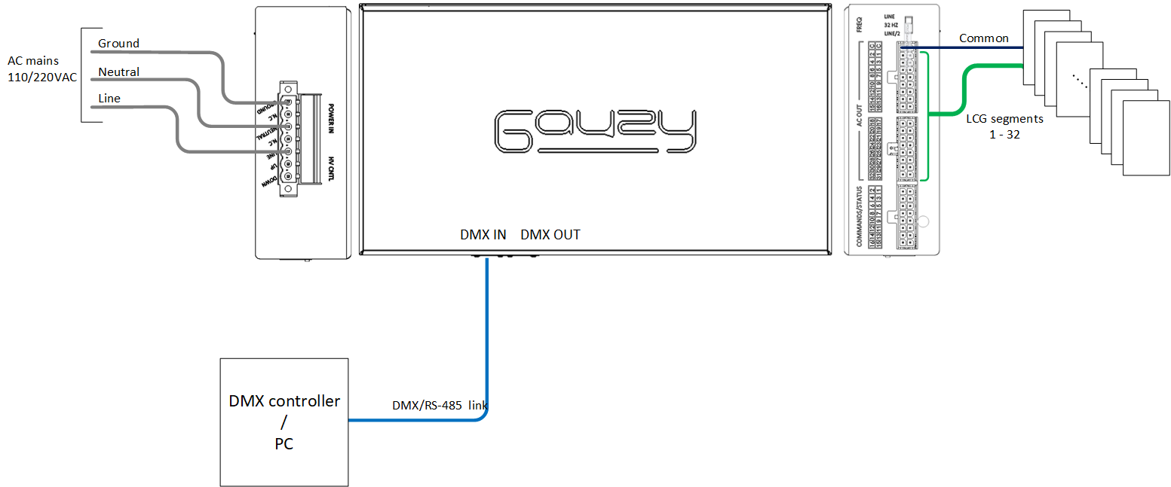

Connecting the Multiplex controller for digital interfaces

1. **Before proceeding make sure the main AC voltage is disconnected. Any electrical connection should be done by a qualified electrician.**
2. Connect AC mains to the LINE, NEUTRAL and GROUND terminals respectively.
3. Connect the supplied MOLEX microfit cable to the AC OUT connectors of the controller. The cable has two connectors, one 18-pin for outputs 1-16 with the two COMMON terminals, and a second for outputs 17-32.
4. Connect the open lead wires of the cable to the number of LCG panels used according to their defined number.
5. The wire labeled CMN is the common signal and should be connected to all LCG panels/segments. The following image shows connection of 4 LCG to one Multiplex



1. Connect the DMX IN port on the Multiplex to the DMX controller or a PC using a RS-485 half-duplex link according to the preferred operation mode. Use the following pinout for the cable.
   * 1 DATA +
   * 2 DATA –
   * 7 GND

## Configuring the Multiplex for DMX/COM operating modes

The Multiplex can work in one of two modes: (1) DMX or (2) COM API using RS-485 link. The selection and configuration between these two modes is done via a HyperTerminal.

1. Connect the DMX IN port on the Multiplex to a PC or laptop. A USB-RS485 converter can be used for this purpose.
2. Open a hyper terminal application and establish connection with the specific COM port. Use the following link parameters

* Baud rate 9600
* Data bits 8
* Parity NONE
* Stop bits 1

1. Turn the AC mains ON by plugging the power cord to the power outlet or press the reset button on the controller.
2. A configuration menu should be displayed.

The menu displays the SW version and the current configuration mode.

1. Configure the Multiplex controller according to the description bellow:

|  |  |  |  |  |
| --- | --- | --- | --- | --- |
| **Command** | **Command name** | **Description** | **Syntax** | **Examples** |
| Set DMX ID | A | Sets the DMX base address designated to the controller. | A<*decimal, 3 digits*> | A001  A009 |
| Get DMX ID | B | returns the DMX base address of the controller | B | 001  009 |
| Get HW Ver | C | returns the HW version of the controller | C | HW Ver |
| Get SEC Number | D | returns the number of SEC cards installed in the controller | D | XXXX  Where x:  1 – SEC installed  0 – SEC not installed |
| Get SEC HW Ver | E | Gets the SEC HW version | E | SEC HW Ver |
| Get Status | F | returns information on the status of the controller | F |  |
| Set Mode | G | Sets the operating mode of the controller | G<*0 or 1*>  0 – DMX mode  1 – COM mode | G0  G1 |
| Set Channel Value | H | Set channels value in COM mode | H<*8-bit HEX value*> | H00000000  H01AA00AA  HFFFFFFFF |
| Print Menu | P | Prints the menu | P |  |
| Run DMX | X | Runs the controller in DMX mode | X |  |

1. After configuration is completed press the reset button on the controller and verify the configuration done.
2. For DMX interface switch the cable from the PC to the DMX controller and after 30 seconds the device should sync to the DMX link and the status LED will blink.

## 

## Working with the DMX interface

The Multiplex controller has 32 channels that are divided in 4 groups of 8 channels.

Each group is mapped to a different DMX timeslot with the base address designated in the DMX ID defined in the configuration menu. For example if the DMX ID defined is 1, then

* Timeslot 1 – channels 1-8
* Timeslot 2 – channels 9-16
* Timeslot 3 – channels 17-24
* Timeslot 4 – channels 25-32

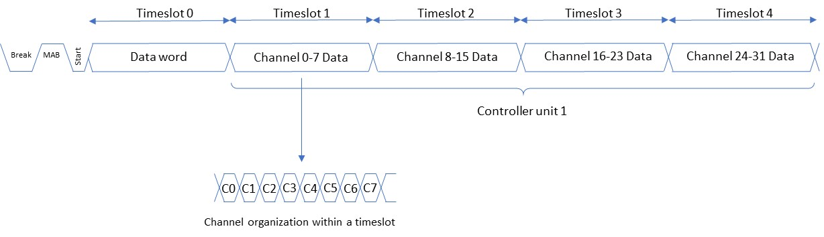

Each data timeslot is composed of a 8-bit word that refers to 8 channels in the Multiplex controller. One full 32 channel controller will allocate 4 timeslots in the DMX512 frame allowing a total of 128 controllers to reside in one DMX512 link (Universe).

When having more than one Multiplex controller connected to the same DMX link addressing must be done in such a way to avoid overlapping of the channels of the controllers.

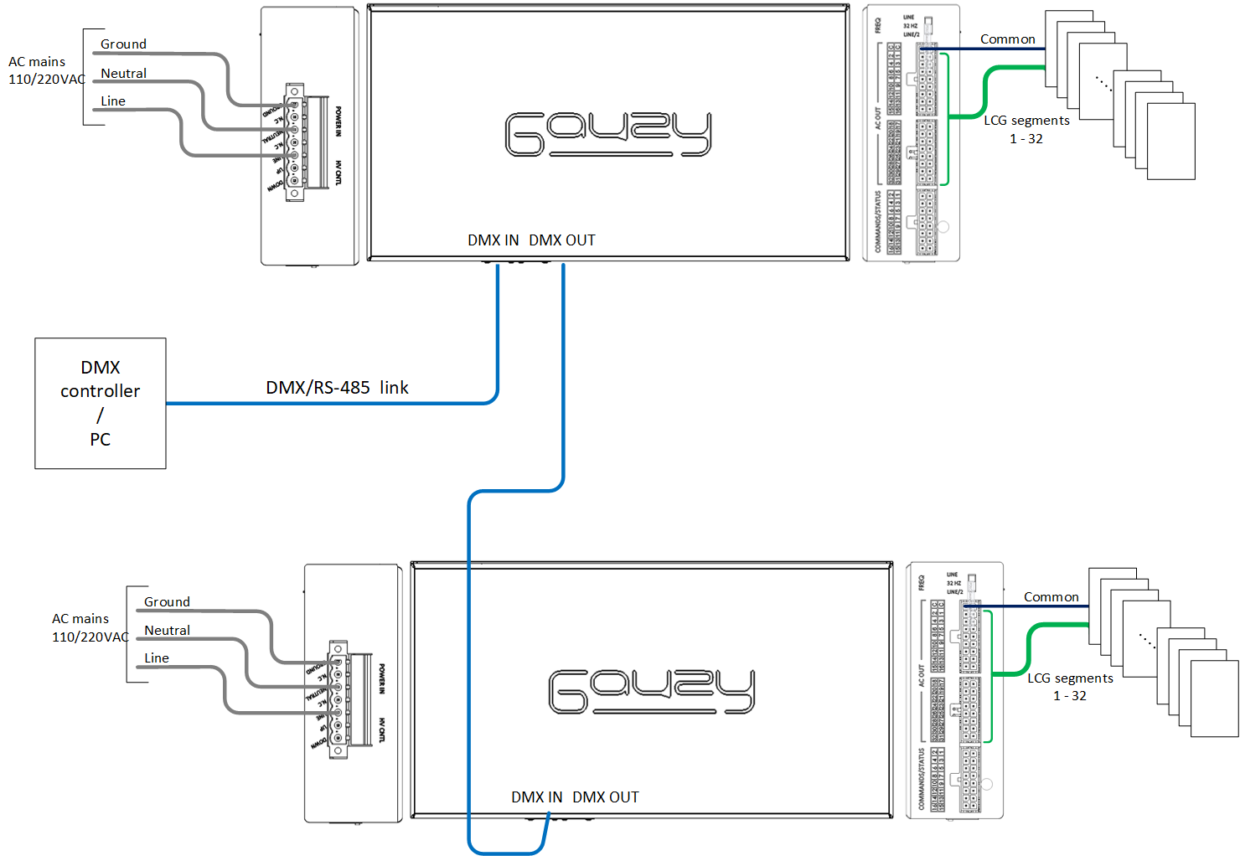

The following table shows and example for a DMX link with 4 Multiplex controllers.

|  |  |  |  |  |
| --- | --- | --- | --- | --- |
| **Timeslot 0** | **Packet Timeslot** | **Device Channels** | **Multiplex controller** | **Data values** |
| 0x00  NULL START | 1 | 0 – 7 | 1 | 0 – LCG Off  1 – LCG On |
| 2 | 8 – 15 |
| 3 | 16 – 23 |
| 4 | 24 – 31 |
| 5 | 0 – 7 | 2 |
| 6 | 8 – 15 |
| 7 | 16 – 23 |
| 8 | 24 – 31 |
| 9 | 0 – 7 | 3 |
| 10 | 8 – 15 |
| 11 | 16 – 23 |
| 12 | 24 – 31 |
| 13 | 0 – 7 | 4 |
| 14 | 8 – 15 |
| 15 | 16 – 23 |

## Working with the COM Mode interface

When used in COM mode all 32 channels can be accessed from a PC with a simple API using a RS-485 link.

The COM mode works with the following configuration

* Baud rate 9600
* Data bits 8
* Parity NONE
* Stop bits 1

In COM mode, only a single controller can be connected to the link, thus this is a point to point connection and not a daisy chain like the DMX protocol.

A simple command is defined to control each of the 32 channels:

H <32 channel status in HEX>

For example

**H**00000000 – turns off all the 32 channels

**H**FFFFFFFF – turns On all the 32 channels

**H**0000FFFF – Turns Off channels 17-32 and turns On channels 1-16

**H**10008003 – turns Off all channels EXCEPT channels 1, 2, 16 and 29 which are On.

## Frequency Switching

Gauzy’s LCG controllers have the capability to adjust the operating frequency of the LCG to adapt itself and prevent flickering effects under certain lighting conditions. In addition to that, the lower the frequency used, less power is consumed by the LCG.

The LCG can work at the following settings:

1. LINE – LCG operates at the line frequency and is synchronized to Line frequency. (50/60 HZ depending on country of use)
2. 32HZ – LCG operates at a frequency of 32 Hz, and is not synchronized to the line
3. LINE/2 – LCG operates at half the line frequency and is synchronized to the line frequency (25/30 HZ depending on country of use)

In order to define the operating frequency of the LCG use the switch located at the side panel of the controller.

## General Installation Guidelines

* Before any initial step you do, read carefully this installation guide. Keep it for future use.
* After opening the product’s package, make sure the device is in a good condition, and there is no breakage visible. If you have any doubt about the product’s integrity, please contact Gauzy’s support center.
* Before connecting the device for the first time, make sure the voltage and frequency of your AC network match the electrical specification of this unit.
* Before connecting this unit to the LCG, make sure this controller model matches the LCG electrical specification requirements.
* Proper use of this device requires connecting the AC input GROUND terminal to earth.
* The electrical connections of this device must be made by a qualified electrician.
* This device was designed to work for the purposes it was designed for. Connecting this device to other type of load rather than LCG may damage the device. Gauzy Ltd. Will not be responsible for any damaged cause by inappropriate usage of this device.
* This device is for indoors use only.
* This device is to be used in a permanent connection.

The following table describes the wires and conductors that must be used for the installation

|  |  |
| --- | --- |
| AC Input & HV Controls | At least 1mm2/16AWG Conductors rated for 110/220 VAC |
| Dry Contacts LV Controls | 18 - 24AWG wires. |
| AC OUT (Connection to LCG) | At least 0.2mm2 /24AWG conductors (*) |

(*) – Conductor thickness depends on the total area of LCG connected and the distance of the LCG to the controller.

* The connection of the controller to the electrical cabinet always should be done through a circuit breaker with a rating of 6-10A type B
* The device is suitable for wall mounting, or to be installed inside an electrical cabinet.
* The installation should always allow enough place for natural ventilation of the unit.
* Never leave wire conductors exposed. If needed use isolation tape to cover the unit's terminals